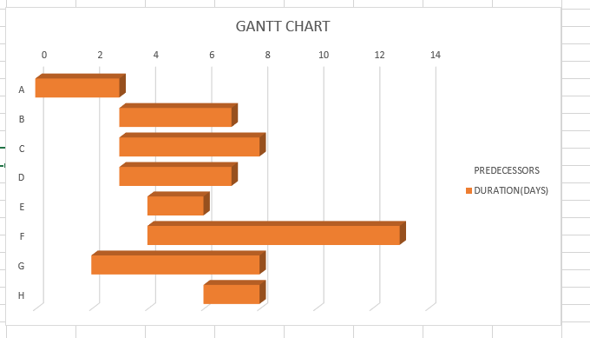

2)

|  |  |  |  |  |  |
| --- | --- | --- | --- | --- | --- |
| Activity | Earliest Start  (ES) | Earliest Finish  (EF) | Latest Start  (LS) | Latest Finish  (LF) | Slack time  ( LS – ES) |
| A | 0 | 3 + 0 = 3 | 3 – 3 = 0 | 3 | 0 |
| B | 3 | 3 + 4 = 7 | 7 – 4 = 3 | 4 | 0 |
| C | 3 | 3 + 5 = 8 | 8 – 3 = 5 | 5 | 2 |
| D | 3 | 3 + 4 = 7 | 7 – 4 = 3 | 4 | 0 |
| E | 4 | 4 + 2 = 6 | 6 – 2 = 4 | 2 | 0 |
| F | 4 | 4 + 9 = 13 | 13 – 9 = 4 | 9 | 0 |
| G | 2 | 2 + 6 = 8 | 8 – 6 = 2 | 6 | 0 |
| H | 6 | 6 + 2 = 8 | 8 – 2 = 6 | 6 | 0 |

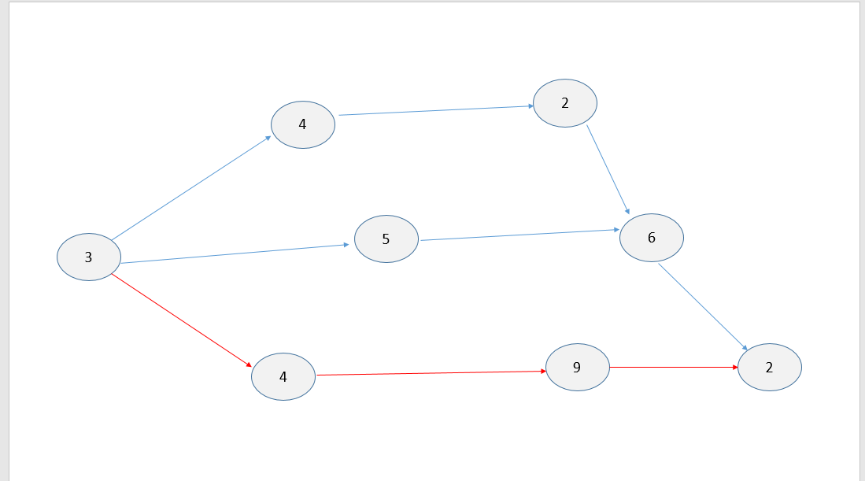

Critical tasks = A + D + F + H = 3 + 4 + 9 + 2

Duration = 3 + 4 + 9 + 2 = 18 days.